1. Install:

sudo apt install dracut-core

1. Create derictory:

mkdir -p /usr/lib/dracut/modules.d/01test

1. Add files module-**setup.sh** and **test.sh**.

Content of files:

*********************************

*rustam4@rustam4-VirtualBox:/usr/lib/dracut/modules.d/01test$ cat module-setup.sh*

*#!/bin/bash*

*check() {*

*return 0*

*}*

*depends() {*

*return 0*

*}*

*install() {*

*inst_hook cleanup 00 "${moddir}/test.sh"*

}

*********************************

rustam4@rustam4-VirtualBox:/usr/lib/dracut/modules.d/01test$ cat test.sh

#!/bin/bash

exec 0<>/dev/console 1<>/dev/console 2<>/dev/console

cat <<'msgend'

Hello! You are in dracut module!

___________________

< I'm dracut module >

-------------------

\

\

.--.

|o_o |

|:_/ |

// \ \

(| | )

/'\_ _/`\

\___)=(___/

msgend

sleep 10

echo " continuing...."

*********************************

1. Recreate initrd:
2. Command mkinitrd not worked:

rustam4@rustam4-VirtualBox:/usr/lib/dracut/modules.d/01test$ mkinitrd -f -v /boot/initramfs-$(uname -r).img $(uname -r)

mkinitrd: команда не найдена

1. Used

**dracut -f -v**

1. Check result:

$ sudo lsinitrd -m /boot/initramfs-$(uname -r).img | grep test

[sudo] пароль для rustam4:

test

1. Change settings /etc/default/grub:

2 ways:

1. Via vim: sudo vim /etc/default/grub.
2. Or install grub customieser:

**sudo add-apt-repository ppa:danielrichter2007/grub-customizer  
sudo apt-get update  
sudo apt-get install grub-customizer**

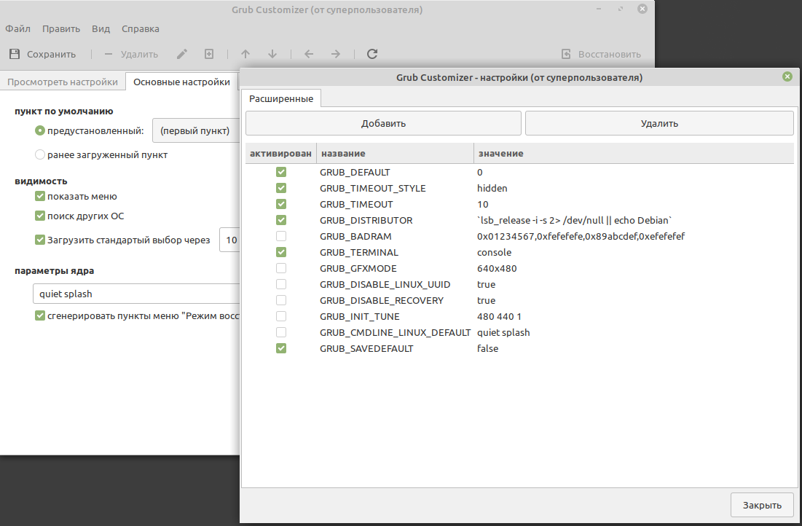

1. Result:

rustam4@rustam4-VirtualBox:/usr/lib/dracut/modules.d/01test**$ cat /etc/default/grub**

# If you change this file, run 'update-grub' afterwards to update

# /boot/grub/grub.cfg.

# For full documentation of the options in this file, see:

# info -f grub -n 'Simple configuration'

GRUB_DEFAULT="0"

GRUB_TIMEOUT_STYLE="hidden"

GRUB_TIMEOUT="10"

GRUB_DISTRIBUTOR="`lsb_release -i -s 2> /dev/null || echo Debian`"

#GRUB_CMDLINE_LINUX_DEFAULT=""

GRUB_CMDLINE_LINUX=""

# Uncomment to enable BadRAM filtering, modify to suit your needs

# This works with Linux (no patch required) and with any kernel that obtains

# the memory map information from GRUB (GNU Mach, kernel of FreeBSD ...)

#GRUB_BADRAM="0x01234567,0xfefefefe,0x89abcdef,0xefefefef"

# Uncomment to disable graphical terminal (grub-pc only)

GRUB_TERMINAL="console"

# The resolution used on graphical terminal

# note that you can use only modes which your graphic card supports via VBE

# you can see them in real GRUB with the command `vbeinfo'

#GRUB_GFXMODE="640x480"

# Uncomment if you don't want GRUB to pass "root=UUID=xxx" parameter to Linux

#GRUB_DISABLE_LINUX_UUID="true"

# Uncomment to disable generation of recovery mode menu entries

#GRUB_DISABLE_RECOVERY="true"

# Uncomment to get a beep at grub start

#GRUB_INIT_TUNE="480 440 1"

#GRUB_CMDLINE_LINUX_DEFAULT="quiet splash"

GRUB_SAVEDEFAULT="false"

1. Reboot
2. Check output during restart:

